Wireless Communication Lab
Lab Manual No 02

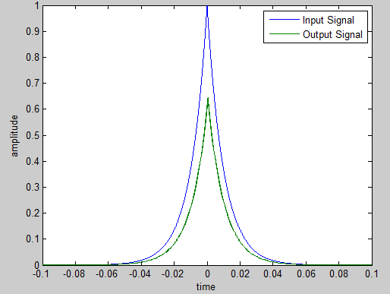
Topic: Simulation of Communication Systems Using MATLAB
Name: ____________________
Roll No: ____________________
Semester: 6th
Sec: Alpha / Omega

Objectives:-
The main objective of this session is to learn the basic tools and concepts for simulating
communication systems using MATLAB.
Introduction:-
MATLAB is a user-friendly, widely used software for numerical computations. MATLAB is
vector-oriented, that is, it mainly deals with vectors (or matrices). It is assumed that you
have used MATLAB before, and you can do simple operations, as well as create and run *.m
files. We advise you to read Lab Manual No 01 for MATLAB review.
Our focus in this session will be on using MATLAB for simulating communication systems.
Instead of going in the traditional approach of explaining items individually, we will work
through one complete example, and introduce the application as we go.
Case Study:
Write a MATLAB program to simulate the following system
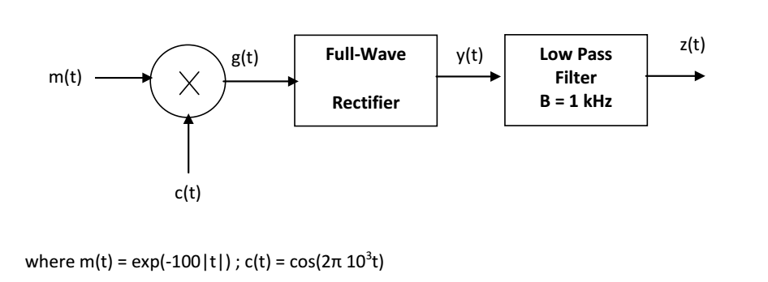

m-File:
% Define the time interval
ts=0.00001;
t= -0.1:ts:0.1;

% Define the functions m(t) and c(t)
m=exp(-100*abs(t));
c=cos(2*pi*1000*t);

% Performe the multiplication
g=m.*c;

% Perform full-wave rectification
y=abs(g);

% Create the filter
cutoff=1000;
[a b]=butter(5,2*cutoff*ts);

% Get the output after the filter;
z=filter(a,b,y);

% Plot the input and output on the same graph
figure (1)
plot(t,m,t,z);
legend('Input Signal','Output Signal')
xlabel ('time')
ylabel('amplitude')
title ('Case Study')

% Finding the FT of the signals
M=abs(fftshift(fft(m)));
G=abs(fftshift(fft(g)));
Y=abs(fftshift(fft(y)));
Z=abs(fftshift(fft(z)));

% Creating the vector for the frequency axis
f=[-length(t)/2:length(t)/2-1]/(length(t)*ts);

% Plotting all FT on one sheet, in a 2x2 matrix format
figure (2)
subplot (2,2,1)
plot(f,M)
subplot(2,2,2)
plot(f,G)
subplot (2,2,3)
plot(f,Y)
subplot(2,2,4)
plot(f,Z)

Discussion:-
% Define the time interval
This is usually the first step in any simulation. There are three parameters to define: the
beginning of the interval, the step size, the end of the interval. The beginning and end of the interval are intuitive; for periodic signals you want to cover 3-5 periods; for non-periodic
signals, you usually want to cover the non-zero part of the signal. The selection of the step size is crucial for the accuracy of the simulation. You need enough sample points to represent the signal. Usually, the step size is taken to be of the order of one hundredth of the smallest period in the program (Or, the sampling frequency fs = 1/ts should be 100 times the frequency of the signal). In our example, since we are having c(t) of frequency 1000 Hz, we selected fs = 100000, or ts = 0.00001.

% Define the functions m(t) and c(t)
This is a straightforward step. The function abs stands for | |, while pi=π. Note that the
signals m and c are now vectors of the same size as t.

% Perform the multiplication
This is also a straightforward step. However, note the dot after m. Why this is necessary
here? What would happen if you remove the dot?

% Perform full-wave rectification
This is again a straightforward step, provided you recognize that full-wave rectification is
mathematically equivalent to taking the absolute value.

% Create the LPF
This operation is frequently encountered in simulating communication systems. A LPF is
defined by one parameter, the cutoff frequency. A filter in MATLAB is represented by its transfer function. The transfer function is in general in the form of the division of two polynomials. The filter is completely defined by the coefficients of the polynomial at the numerator and the polynomial at the denominator. These are the vectors a and b respectively in the program. There are many realizations for designing filters. One common realization is Butterworth, which is the one used here, hence the function name butter.
The butter function has two arguments. The first argument is the order of the filter. The
larger the order the sharper the filter (closer to ideal), but more processing is required. For
most of our applications an order of 3-5 should be sufficient.
The second argument is a coefficient related to the cutoff frequency. Without going into the
details of the derivation, to design a LPF filter of cutoff frequency W, the argument should
be set to 2*W*ts, where ts is the time step size of the program. For more details about the
command butter , type:

>> help butter ; in the MATLAB prompt
How many arguments would a BPF require? What are they?
% Get the output after the filter;

In the previous step we have only created the filter. To apply the filter to a given signal, we
use the function filter. This function has three parameters: the coefficients of the filter a and
b, and the vector to be filtered. Note that although we think of the filter operation in
frequency domain, the filter function operates on a time-domain vector. The output should
as well be taken as a time-domain vector.

% Finding the FT of the signals
The Fourier Transform of signals can be found in MATLAB using the function fft. It can be
used with a single argument, which is the time-domain vector. The fft function yields only
the positive side of the spectrum. To get the double-sided spectrum, augment fft by fftshift.
Finally, if you are only interested in the amplitude spectrum, augment all by the function
abs. The resulting frequency-domain vector will have size one less than the size of the input
time-domain vector.

% Creating the vector for the frequency axis
To plot the frequency spectrum as a function of frequency, you need to create the frequency
axis. The available range of frequencies depends on ts, and is given by the relation:
f=[-length(t)/2:length(t)/2-1]/(length(t)*ts);
% Plotting
We leave this step to the student to explore. Use the help command to read about plot
subplot, figure, legend, xlabel, ylabel, title and axis commands.

Lab Tasks:

- Create and run the m-file above, and produce Figure (1) and (2).
- Change m(t) to 2+ sin(2π*1000t) and c(t) to cos(2π*10⁴) and the cutoff frequency of the filter to 2 kHz. Redo part 1.

- Using MATLAB, add the signals m(t) = exp(-100|t|) and c(t) = cos(2π*10³t) then separate them by means of filtering only (LPF and BPF). Provide the m-file and a plot
of the sum in time and frequency, and of each of the recovered signals in time and frequency.

